**what is MVC ?**

MVC stands for model view controller

MVC used to make a dynamic website or web application in php

MVC is simple an architecture i.e stands for model | view and controller

MVC create a secured web applications or website.

MVC is used to support OOPS (object oriented programming structure language)

MVC is used to support access modifier or specifier to protect data or secured web applications.

PUBLIC | PRIVATE | Protected

**Model :** Model is used to connect with database and create a member function in model

**View :** View is used to create an GUI part of website graphical user interface it meanse all template | from are used or create in view .

**Controller :** Controller is used to handel a logic part of your applications.

**MVC architecture :** MVC stands for model view controller its an architecture i.e used to create a dynamic web application or website.

MVC is model view and controller i.e used to seprate a logic in form of model , view and controller.

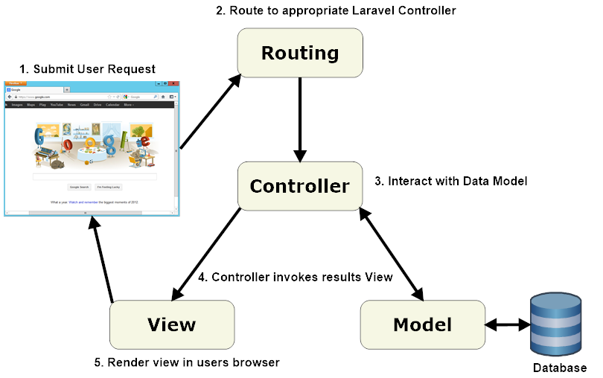

**Model**

Model.php

<?php

class Model

{

    public $connection="";

    public function __construct()

    {

        // database connections

        //exception handeling

        try

        {

        $this->connection=new mysqli("localhost","root","","mvcmyapp");

        // echo "connection successfully";

        }

        catch(Exception $e)

        {

            die(mysqli_error());

        }

    }

}

?>

**Controller**

Controller.php

<?php

require_once("model/model.php");

class Controller extends Model

{

    public function __construct()

    {

        //logic : WAP to print your name take input from users

        parent:: __construct();

        // set buttons

        if(isset($_POST["sub"]))

        {

            $nm=$_POST["nm"];

            echo "<h3 align='center' style='color:green'>Your name is : $nm</h3>";

        }

    }

}

$obj=new Controller;

?>

**View**

Index.php

<?php

require_once("controller/controller.php");

?>

<!DOCTYPE html>

<html>

<head>

    <meta charset='utf-8'>

    <meta http-equiv='X-UA-Compatible' content='IE=edge'>

    <title>Page Title</title>

    <meta name='viewport' content='width=device-width, initial-scale=1'>

    <link rel='stylesheet' type='text/css' media='screen' href='main.css'>

    <script src='main.js'></script>

</head>

<body>

<center>

   <h3>Check your Name</h3>

<form method="post">

    Enter your Name :<input type="text" name="nm" placeholder="Enter your name">

    <br><br>

    <input type="submit" name="sub" value="Submit">

</form>

</body>

</html>